State of Charge Monitor

Use temperature, voltage and bi-polar current measurements with a programmable logic controller to reliably monitor the state of charge of a domestic LifeP04 battery bank that is charged by various sources.

Dave Gutz January 12, 2023 first draft

Abstract:
Users of rechargeable battery banks need to know how much charge remains. This becomes important for estimating the range of travel for an electric car, for example – the 'gas gauge replacement.' In my case, when truck camping with my CPAP machine I need to know if there is enough charge in the RV battery bank to power the CPAP overnight. I've never woke up gasping and I want to minimize that possibility. Old technology batteries, e.g. Lead-acid, have a steep curve relationship between terminal voltage and state-of-charge (SoC). This makes it easy to use a voltmeter as a SoC gauge. Newer batteries developed for electric cars are different. The flat voltage-SoC characteristic of modern LiFeP04 batteries – safe to install in sleeping quarters and efficient charge handlers – makes it nearly impossible to guess SoC from voltage measurement. Further complicating the task, the electrical hysteresis where voltage depends on direction of charging/discharging and time history is large compared to the SoC characteristic. Hysteresis uncertainty approaches the entire SoC curve from fully discharged to fully charged. A 'smart,' reliable monitor is needed. Smart would be capabilities that keep track of the time history to as accurately as possible predict time remaining for current usage. Reliable would be features that keep the system operational in the presence of common failures, allowing the user to repair the system at their convenience with no downtime. At present, my system is designed for a couple, one-off prototypes and relies on calibration of inexpensive components for precision. The known condition of full saturation is easily detected and used to re-calibrate the device on the fly. Hardware RC filtering is needed to cleanup the sensor signals from noise injected by AC inverter devices. A 1 Hz low-pass anti-alias filter in hardware is all that is needed. Since SoC is a long term, e.g. 24 hour integration process – a very slow low-pass filter in itself, no precision is lost using the hardware RC filtering. Therefore advanced software filtering is not required for the main task of counting Coulomb charge. An Extended Kalman Filter (EKF) advanced filtering is useful, however, to detect component failures and establish reliability. I used Mathworks' EKF prototype. I created my own 'reservoir' charge model to track hysteresis. I found that reasonable reliability is achieved with simplex temperature sensing, simplex voltage sensing, and dual current sensing. The combination of two current signals, one voltage sensor, the EKF, and known SoC characteristic (voltage-currrent-time history) enables the equivalent of triplex current sensing. Quiet signal detection logic detects that a current sensor is disconnected either by wiring or failure to help isolate. For strictly hardware reliability reasons, the 1-wire temperature sensor and the mini-OLED display are line replaceable. Faults and history are recorded in EERAM for later retrieval. A standalone Python data reduction program (DRP) allows comparing history with a model to understand operation. The DRP also serves as regression machine to compare software changes with past changes, to develop component maps for characterizing a system, and to investigate problems. Some learnings: The system needs to run at about 0.1 seconds update to accurately capture by integration the peaks and valleys of battery bank usage. The EKF needs to run double precision as well as slower update rate, about 0.5 seconds, to handle the numerics of the system. It is possible to self-calibrate by comparing total charge history to total discharge history between known charge states – full charge. By triangulation of data history, the charging efficiency of the batteries needs to be estimated to complement the history data. System uncertainty for this home-made system is large so that this self-calibration adds no value and was omitted from the published version. Simple scalar-adder calibration of the installed current sensor using a clamping current meter is sufficient to establish monitor precision within about a half hour of time remaining estimate. To calibrate the system, the user needs to be intentionally discharged and recharged at expected operating temperatures to characterize the SoC-voltage (voc(soc)) map and hysteresis model. Triangulation of data, IE. repeated calibration runs from full charge to full discharge, allows estimation of the battery capacity versus rated while calibrating the current sensors (full charge condition is repeatable). In the case of a CPAP system, I used a couple household fans to simulate actual load and ran data collection overnight in the driveway with the fans while I slept in the house with my CPAP. Battery life may be monitored by repeat calibration. Most of my findings are preliminary based on my observations of prototypes and a lot of experience in the development of computer controlled systems. I took advantage of my 'skunk works' arrangement in retirement. Rigorous study is needed to establish the findings as fact for some product device.

Off-the-Shelf Hardware Description
I used prototype boards to connect various off-the-shelf devices into a reliable, maintainable box. The heart of the system is the Particle programmable logic controller (PLC). I've incorporated both the Particle Photon device gen 1 device and the Particle Argon gen 3 device. Figure 1 shows the latest Argon schematic using Stripboard, a prototyping 0.1 inch spaced board that underneath connects vertical elements with layered copper conductors and over the top and bottom connects signals into bus bars and horizontal elements that connect v+ and v- into bus bars. The Photon is no longer available so I didn't bother to show a schematic. It is similar without the 47L16 device but with a battery connected to VBAT. The Argon will disappear soon too probably in 2023. The recommended replacement is Photon 2. In the future I suggest getting the Photon 2 developer kit that has headers and other peripherals such as USB installed.

It doesn't matter which of the old generation boards are used. The Photon uses an external CR2040 battery to energy EERAM while the Argon uses a peripheral 47L16 EERAM device that saves to EEPROM when it detects loss of power, using an external capacitor to power itself while doing so. The SOC_Particle application uses #define to configure for either board. When the use 'Configure for device' on the Particle Workbench Visual Studio IDE and select the Particle device, Argon and give it a name, it automatically configures the global #defines to allow you to select the correct #define locally for your own use. Giving it a name checks that you're loading the proper device that you configured for.

Device names are given using the Particle App with the device in Setup mode (push left button for 3 seconds to get blinking blue light).

The 47L16 EERAM device provides memory to the Argon through power loss, sometimes caused by the battery management system (BMS) of the battery itself as well as user events.

OPA333 op-amp circuits, two for reliability, convert the bipolar +/- 0.075 volt Bayite shunt signal, current range 100 Amps, into full range 0-3.3v A/D signal. The current signal uses a dedicated, shielded sense line to feed high impedance op-amp circuits to avoid line effects.

A voltage divider circuit measures battery voltage straight from the device power supply. Caution: the Particle devices blow if A/D voltage exceeds 3.3v. If the prototype is used on a two-battery series 2S system, the voltage divider circuit needs modification.

A 12v – 5v converter circuit feeds power to the Particle device and the 1-wire temperature sensor. The Particle device in turn converts 3.3 v for other devices – op-amp, EERAM and OLED display. The Particle device also has a USB. The power demands do not exceed the capacity of the Particle so USB-only usage is possible for user off-line testing. Measurement of 12v supply is missing in this mode.

All the hardware if the least expensive possible. Battery uncertainty drives accuracy. And low rate of production make use of user calibration feasible.

The initial battery used to test the system, and use on RV trips, was the Battleborn 100 A-h LiFeP04. It is the most expensive battery available and comes with an industry-leading BMS that prevents damage from misuse. I thought that was important for the first prototype. Chins batteries are available at 1/3 the price.
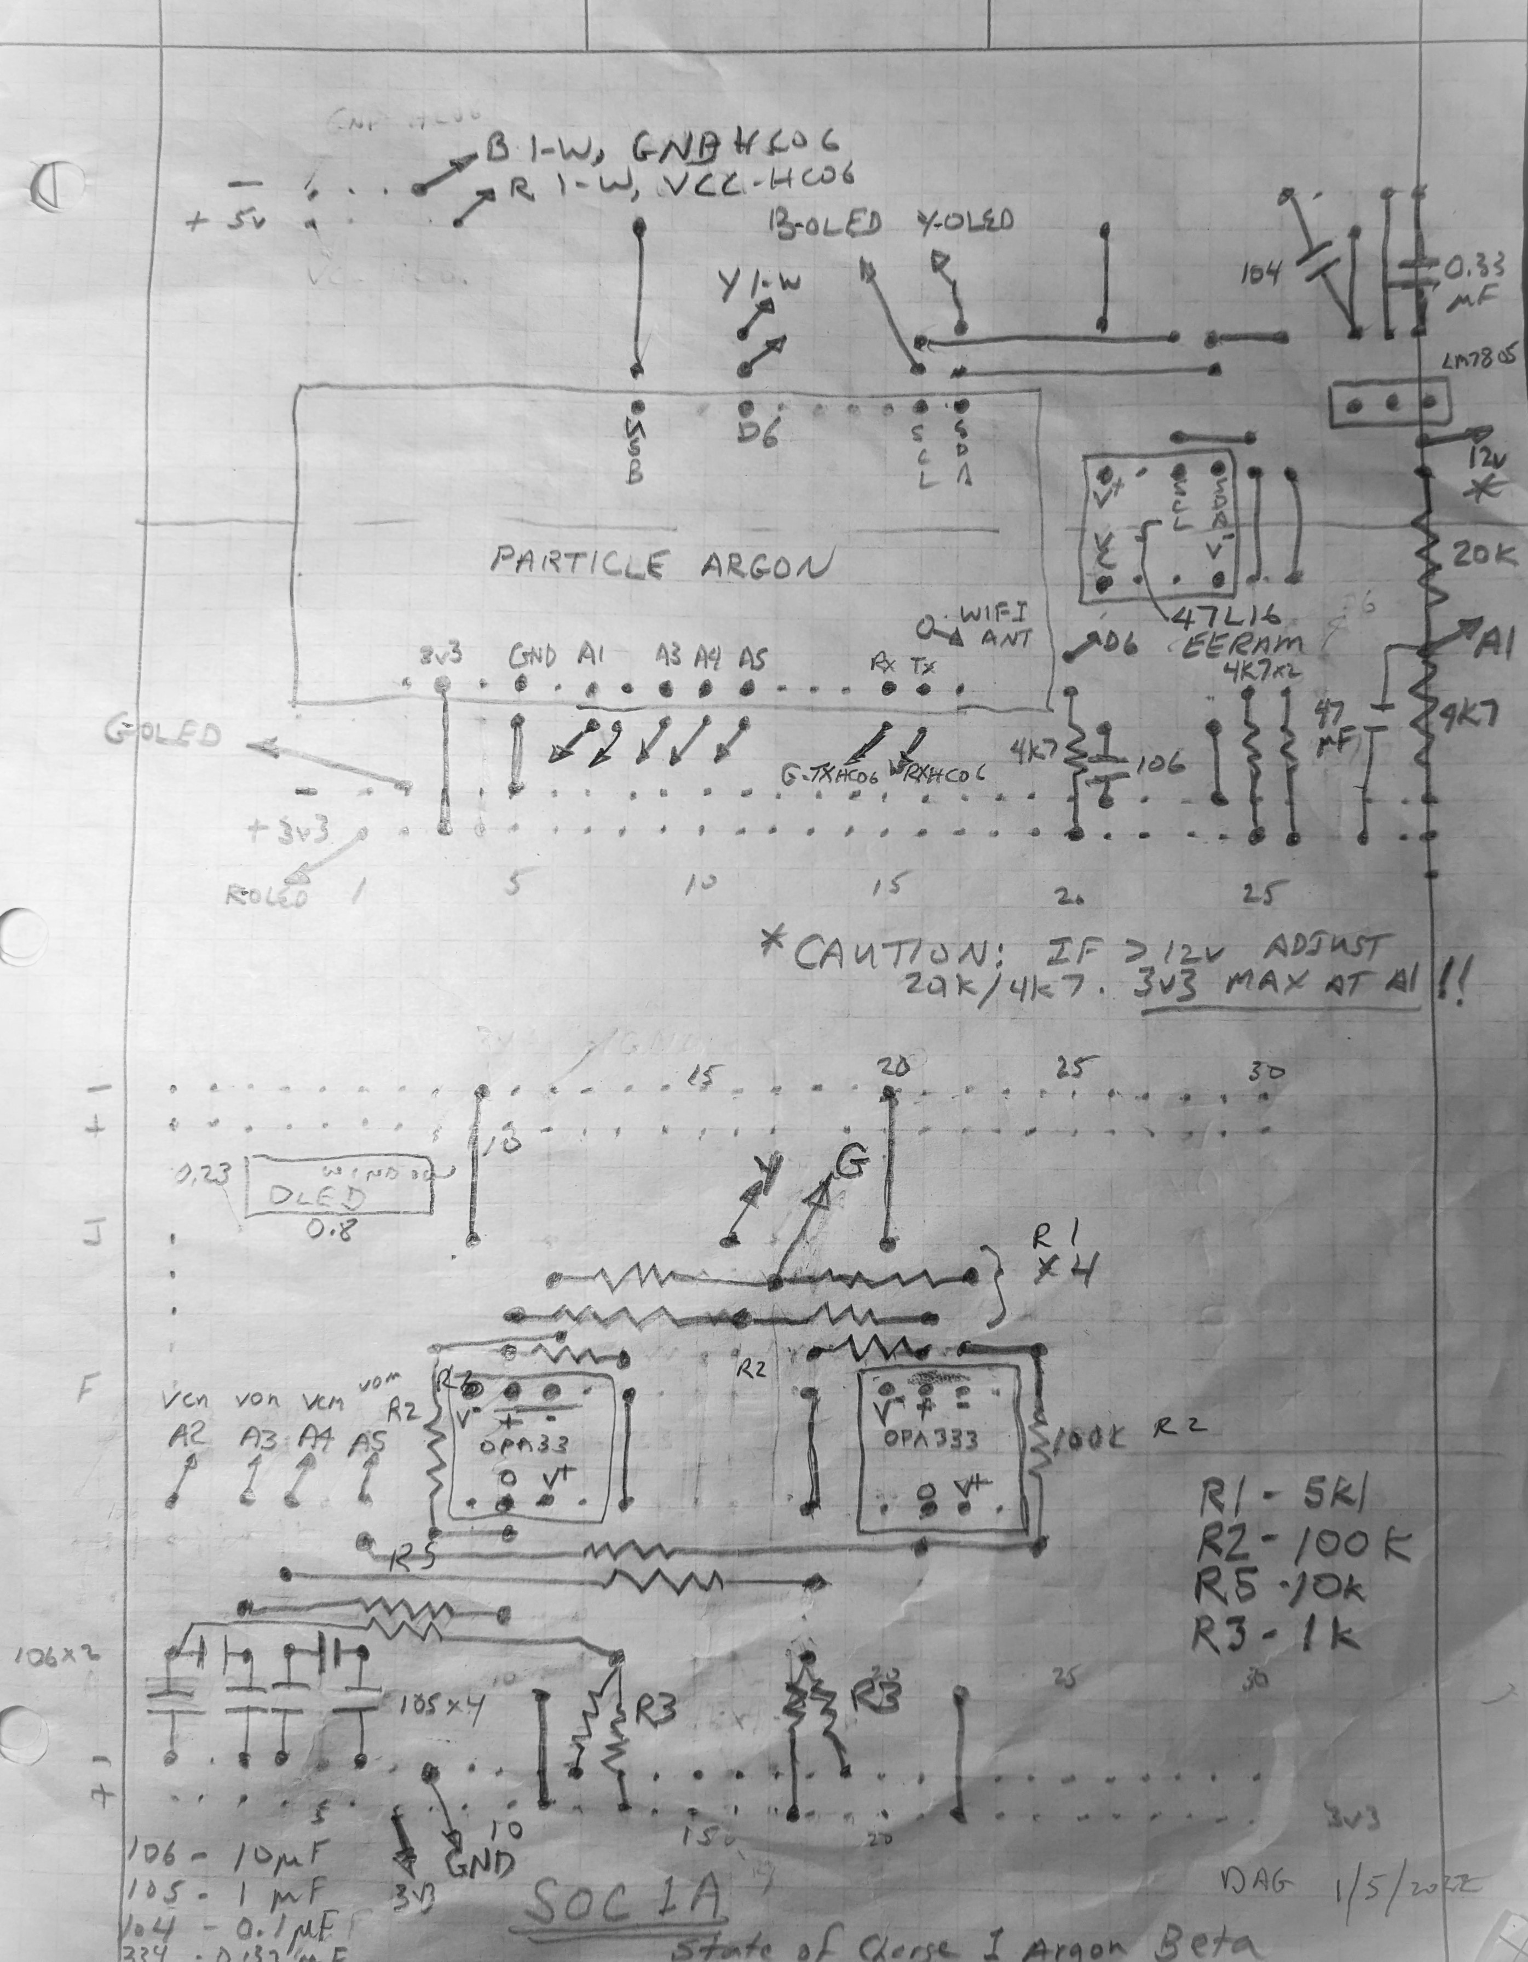Figure 1: State of Charge Wiring Diagram Board Layout

Requirements
In the spirit of Software Engineering principles, I document perceived requirements. Many of these arose out of testing.

- Calculate state of charge of 100 Ah Battleborn LiFePO4 battery. The state of charge is percentage of 100 Ah available.
a. Nominally the battery may have more than 100 Ah capacity. This should be confirmed.
b. Displayed SoC may exceed 100 but should not go below 0.
- Displayed values when sitting either charging slightly or discharging DC circuits (no inverter) should appear constant after filter rise.
a. Estimate and display hours to 1 soc. (charge is positive). This is the main use of this device: to assure sleeper that CPAP, once turned on, will last longer than expected sleep time.
b. Measure and display shunt current (charge is positive), A.
c. Measure and display battery voltage, V.
d. Measure and display battery temperature, F.
- Implement an adjustment 'talk' function. Along with general debugging it must be capable of
a. Setting soc state
b. Separately setting the model state
c. Resetting pretty much anything
d. Injecting test signals
- CPU hard and soft resets must not change the state of operation, either soc, display, or serial bus.
- Serial streams shall have an absolute Julian-type time for easy plotting and comparison.
- Built-in test function, engaged using 'talk' function.
- Load software using USB. WiFi to truck or phone (hotspot) may not be reliable. Related requirement: provide holes to press Particle Device buttons: sometimes setup long-press needed or manual flash request needed with these devices.
- Likewise, monitor USB using laptop or phone. 'Talk' function should change serial monitor and inject signals for debugging.
- Device shall have no effect on system operation. Monitor function only.
- Bluetooth serial interface required. ***This did not work due to age of Android phone (6 yrs) not compatible with the latest Bluetooth devices.
- Keep as much summary as possible of soc every half hour: Tb, Vb, soc. Save as SRAM battery backup memory. Print out to serial automatically on boot and as requested by 'Talk.' This will tell users charging history.
- Adjustments to model using talk function should preserve delta_q between models to preserve change from saturated situation. The one 'constant' in this device is that it may be reset to reality whenever fully charged. Test it the same way. The will be separate adjustment to bias the model away from this ('n' and 'W')
- The 'Talk' function should let the user test a lot of stuff. The biggest short coming is that it is a little quirky. For example, resetting the Particle device or doing any number of things sometimes requires the filters to be initialized differently, e.g. initialize to input rather than tending toward initializing to 0. The initialization was optimized for installed use. So the user needs to get used to rationalizing the initialization behavior they see when testing. They can wait for the system to settle, sometimes 5 minutes. They can run Talk('Rs') to attempt a software filter reset - won't help if the test draws a steady current after reset/reboot.
- Inject hardware current signal for testing purposes. This may be implemented by reconnecting the shunt input wires to a PWM signal from the Particle device.
- [deleted] The PWM signal for injecting test signals should run at 60 Hz to better mimic the 60 Hz behavior of the inverter when installed and test the hardware AAF filters, (RC=2*pi, 1 Hz -3dB bandwidth).
- There shall be a built-in model to test logic and perform regression tests. The EKF needs a realistic response on current to voltage to work properly (H and hx assume a system). The built-in model must properly represent behavior onto and off of limits of saturation and 0.
- The Battery Monitor will not properly predict saturation and low shutoff. It doesn't need to. The prime requirement is to count Coulombs and reset the counter when saturated. The detection of saturation may be crude but always work - this will result in saturation being declared at too low voltage which is conservative, in that the logic will display a state of charge that is lower than actual.
- The Battery Model used for testing shall implement a current cutback as saturation is neared, to roughly model the BMS in the actual system.
- The Battery Monitor shall implement a predicted loss of capacity with temperature. The Battery Model does not need to implement this but should anyway.
- The Battery Model shall be scale-able using Talk for capacity. The Battery Monitor will have a nominal size and it is OK to recompile for different sizes.
- The Battery Model Coulomb Counting algorithm shall be implemented with separate logic to avoid the problem of logic changes confounding regression test.
- The Talk function shall have a method Talk('RR') that resets all logic to installed configuration.
- The default values of sensor signal biases should remain as default values in logic.
- Power loss and resets (both hard and soft) must not affect long term Coulomb counting. This may result in adding a button-cell battery to the VBAT terminal of Particle device and using 'retained' SRAM data for critical states in the logic. It would be nice if loss and resets did not affect Battery Model and testing too.
- 'soc' shall be current charge 'q' divided by current capacity 'q_capacity' that reflects changes with temperature.
- Coulomb counting shall simultaneously track temperature changes to keep aligned with capacity estimates.
- 'SoC' shall be current charge 'q' at the instant temperature divided by rated capacity at rated temperature.
- The monitor logic must detect and be benign that the DC-DC charger has come on setting Vb while the BMS in the battery has shutoff current. This is to prevent falsely declaring saturation from DC-DC charger on.
- Only Battleborn will be implemented at first but structure will support other suppliers. For now, recompilation is needed to run another supplier and #define switches between them.
- The nominal unit of configuration shall be a 12 v battery with a characteristic(soc) and rated Ah capacity. Use with multiple batteries shall include running an arbitrary number of batteries in parallel and then series (nPnS). The configuration shall be in local_config.h and in retained.h. This is called the 'chemistry' of the configuration.
- The configuration shall be fully adjustable on the fly using Talk. If somebody has Battleborn or a LION they will not need to ever recompile and reflash a Particle device.
- Maximize system availability in presence of loss of sensor signals. Soft or hard resets cause signal fault detection and selection to reset. Flash display to communicate signal status: every fourth update of screen indicates a minor fault. Every other update is major fault where action needed. Print signal faults in the 'Q' talk. Add ability to mask faults to a retained parameter rp.

Assumptions
- Randles 2-state RC+RC linear dynamic battery model
- RC 1-state dynamic hysteresis lag with variable resistance, R, constant capacitance, C, and limited authority
- voc(soc) industry standard state-of-charge to voltage characteristic
- Battery has Coulombic charging efficiency
- Coulombic efficiency related to Randles resistances
- All current entering series Randles/Hysteresis model ends up as charge. Transient Randles delta voltage and transient Hysteresis delta voltage store charge but since current is passed along to the Coulomb Counter the Coulomb Counter contains all the charge information if the battery is allowed to settle which it always is.
- Perfect sensor calibration. Book-keep error as an accuracy statement along with modeling errors
- +0.01 fractional change of soc with each degree C bank temperature change
- New batteries have capacity to 105% of rating

Implementation Notes
- An EKF is no more accurate than the open loop voc(soc) curves. As a solver, it does seem to follow through troughs without divergence – a pleasant surprise.
- A Coulomb Counter implementation is very accurate but needs to calibrate every couple cycles to avoid 'infinite wander.' This should happen naturally as the battery charges fully each day.
- Blynk phone monitor implemented, as well as Particle Cloud, but found to be impractical because
a. Seldom near WiFi when camping.
b. OLED display works well.
c. 'Talk' interface works well. Can use with phone while on the go. Need to buy dongle for the phone (Android only): Micro USB 2.0 OTG Cable ($6 on Amazon).
- Shunt monitor seems to have 0 V bias at 0 A current so this is assumed when scaling inputs.
- Current calibrated using clamping ammeter turning large loads off and on.
- Battleborn nominal capacity determined by load tests.
- An iterative solver for voc(soc) model works extremely well given calculable derivative for the equations from reference. PI observer removed in favor of solver. The solver could be used to initialize soc for the Coulomb Counter but probably not worth the trouble. Leave this device in more future possible usage. An EKF then replaced the solver because it essentially does the same thing and was much quieter and could be used for fault detection / isolation.
- Note that there is no effect of the device on system operation so debugging via serial can be more extensive than usual.
- Two-pole filters and update time framing, determined experimentally and by experience to provide best possible Coulomb Counter and display behavior.
- WiFi turned off immediately. Can be turned on by 'Talk('w')'
- Battery temperature changes very slowly, well within capabilities of DS18B sensor.
- 12-bit AD sufficiently accurate for Coulomb Counting. Precision is what matters and it is fine, even with bit flipping.
- All constants in header files (Battery.h and constants.h and retained.h and command.h).
- System can become confused with retained parameters getting off-nominal values and no way to reset except by forcing a full compile reload. So the 'Talk('A')' feature was added to re-nominalize the rp structure. You have to reset to force them to take effect.
- The minor frame time (READ_DELAY) could be run as fast as 5. The application runs in 0.005 seconds. The anti-alias filters in hardware need to run at 1 Hz -3dB bandwidth (tau = 0.159 s) to filter out the PWM-like activity of the inverter that is trying to regulate 60 Hz power. With that kind of hardware filtering, there is no value added to running the logic any faster than 10 Hz (READ_DELAY = 100). There's lots of throughput margin available for adding more EKF logic, etc.
- The hardware AAF filters effectively smooth out the PWM test input to look analog. This is desired behavior: the system must filter 60 Hz inverter activity. The testing is done with PWM signal to give us an opportunity to test the hardware A/D behavior. The user must remember to move the internal jumper wire from 3-5 (testing) to 4-5 (installed).
- Regression test: For installed with real signal, could disconnect solar panels and inject using Talk('Di<>') or Talk('Xp5') and Talk('Xp6'). Uninstalled, should run through them all: Talk('Xp<>,) 0-6. Uninstalled should runs onto and off of limits.
- In modeling mode the Battery Model passes all sensed signals on to the Battery Monitor. The Model does things like cutting back current near saturation, and injecting test signals both hard and soft. The Signal Sense logic needs to perform some injection especially soft so Model not needed for some regression.
- All logic uses a counting scheme that debits Coulombs since last known saturation. The prime requirement of using saturation to periodically reset logic is reflected in use of change since saturation.
- The easiest way to confirm that the EKF is working correctly is to set 'modeling' using Talk('Xm7') and verify that soc_ekf equals soc_mod.
- Lessons-learned from installation in truck. Worked fine driving both A/D with D2 from main board. But when installed in truck all hell broke loose. The root cause was grounding the Vlow fuse side of shunt legs of the A/D converters. In theory the fuse side is the same as ground of power supply. But the wires are gauge 20-22 and I detected a 75 mA current in the Vh and Vl legs which is enough to put about 50% error on detection. Very sensitive. But if float both legs and avoid ground looping it works fine. And as long as ground loops avoided, there is no need to beef up the sense wire gauge because there will be no current to speak of. I revised the schematics. There are now two pin-outs: one for installed in truck and another when driving with the D2 pin and PWM into the RC circuits.
- 'Talk' refers to using CoolTerm to transmit commands through the myTalk.cpp functions. Talk is not threaded so can only send off a barrage of commands open loop and hope for the best.
- I had to add persistence to the 'log on boot' function. When in a cold shutoff, the BMS of the battery periodically 'looks' at the state of the battery by turning it on for a few seconds. The summary filled up quickly with these useless logs. I used a 60 second persistence.
- Use Tb<8 deg C to turn off monitoring for saturation. This prevents false saturation trips under normal conditions.
- Had a failed attempt to heat the battery before settling on what Battleborn does here: <https://battlebornbatteries.com/faq-how-to-use-a-heat-pad-with-battle-born-batteries/>. I thought the pads I bought here: <https://smile.amazon.com/gp/product/B0794V5J5H/ref=ppx_yo_dt_b_asin_title_o05_s00?ie=UTF8&psc=1> would gently heat the batter. I had the right wattage (36 W vs 30 W that Battleborn uses) but I put them all on the bottom. And the temp sensor is on top. And the controller is on/off. That set up a situation where the heat would be on full blast and the entire battery had to heat up before the wave of heat would hit the sensor to shut it off. The wave continued to create about 5 degree C overshoot of temp then 5 degree C undershoot on recovery. I measured up to 180 F at the bottom of the battery using an oven thermometer. There was some localized melting of the case. A model accurately predicted it. See GitHub\myStateOfCharge\SOC_Particle\Battery State\EKF\sandbox\GP_battery_warm_2022a.py. I made a jacket, covered whole thing with R1 camping pad (because BB suggests putting temp sensors inside 'blanket') and put the temp sensor for the SoC monitor and the heater together at one corner about 2 inches down from the top. I set the on/off to run between 40 and 50F (4.4 - 7.2C) compared to BB 35 - 45 F. I wanted tighter control for better data. Maybe after I get more data I'll loosen it back up to 35 - 45 F.
- Calibrated the t_soc voc tables at a 1-4 A discharge rate. Then they charged 5 - 30 A. The hysteresis would have been used some at the 1-4 A rate. May have to adjust tables +0.01 V or so after adding the hysteresis. Measure it: 0.007 V.
- An issue that only show up when using the 'talk' function is an overload of resources that causes a busy waiting of current input reading. I added to readADC_Differential_0_1 count_max logic to prevent forever waiting. There is an optimum because if wait too long it creates cascade wait race in rest of application. 50: inf events. 100:0-4 events. 200: 5 events. 800: 25 events. You can reproduce the problem by sending "Hd" wile running the tweak test of previous item. Apparently exercising the Serial port while reading can cause the read to crash. The actual read statement does not forever wait, but the writer of readADC_Differential_0_1() put a 'while forever' loop around it. I modified the Adafruit code to time out the loop.
- Running the tweak test will cause voc to wander low and after about 5 cycles will no longer saturate. The hysteresis model causes this and is an artifact of running a huge, fast cosine input to the monitor. Will not happen in real world.
- A clean way to initialize the EKF is an iterative solver called whenever initialization is needed. The times this is needed are hard bootup and adjustment of SoC state using Talk function. The latter is initiated using cp.soft_reset. The convergence test persistence is initialized false as desired by TFDelay(false,...) instantiation. Want it to begin false because of the potentially severe consequences of using the EKF to re-initialize the Coulomb Counter.
- The Coulomb Counter is reset to the EKF after 30 seconds with more than 5% error from EKF. Initialization takes care of this automatically. The EKF must be converged within threshold for time(EKF_CONV & EKF_T_CONV).
- To hedge on errors, the displayed amp hours remaining is a weighted average of the EKF and the Coulomb Counter. Weighted to EKF as error increases from DF1 to DF2 error. Set to EKF when error > DF2. Set to average when error < DF1.
- Some Randles dynamics approximation was added to the models, both simulated and EKF embedded to better match reality. I did this in response to poor behavior of the electrical circuits in presence of 60 Hz pulse noise introduced by my system's pure-sine A/C inverter. Eventually I added 1 Hz time constant RC circuits to the A/D analog inputs to smooth things out. I'm not sure the electrical circuit models add any value now. This is because the objective of this device is to measure long term energy drain, time averaged by integration over periods of hours. So much filtering inherent in integration would swamp most of the dynamics captured by the Randles models. It averages out. Detailed study is needed to justify either leaving it in or removing it. An easy study would be to run the simulated version, turning off the Randles model in the Monitor object only. Run the accelerated age test - 'Tweak test' - and observe changes in the Monitor's tweak behavior upon turning off its Randles model. Then and only then it may be sensible to embark on improving the Randles models.
- Given the existing Randles models, note that current is constrained to be the same through series arrangements of battery units. The constraint comes from external loads that have much higher impedance than battery cells. Those cells are nearly pure capacitance. With identical current and mostly linear dynamics, series batteries would have the same current and divide the voltage perfectly. Parallel batteries would have the same voltage and divide the current perfectly. Even the non-linear hysteresis is driven by that same identical current forcing a perfect division of that voltage drop too. So multiple battery banks may be managed by scalars nP and nS on the output of single battery models.
- Throughput test
v1;Dr1;
look at T print, estimate X-2s value (0.049s, ~50% margin)
Dr100;
confirm T restored to 0.100s
- Android running of data collection. The very best I could accomplish is to run BLESerial App and save to file. You can use BLE transmit to change anything, echoed still on USB so flying a little blind. Best for changing 'v0' to 'v1' and vice-versa. The script 'DataOverModel.py' WILL RUN ON ANDROID using PyDroid and a bunch of stupid setup work. But live plots I couldn't get to work because USB support is buggy. The author of best tools usbserial4 said using Python 2 was best - forget that! Easiest to collect data using BLESerial and move to PC for analysis. Could use laptop PC to collect either BLE or USB and that should work really well. Plug laptop into truck cab inverter.
- Capitalized parameters, violation of coding standards, are "Bank" values, e.g. for '2P3S' parallel-serial banks of batteries while lower case are per 12V battery unit.
- Signal injection examples:
Ca0.5;Xts;Xa100;Xf0.1;XW5;XC5;v1;XR;
Expected anomalies:
- real world collection sometimes run sample times longer than RANDLES_T_MAX. When that happens the modeled simulation of Randles system will oscillate so it is bypassed. Real data will appear to have first order response and simulation in python will appear to be step.
- Manual tests to check initialization of real world. Set 'Xm=4;' to over-ride current sensor. Set 'Dc<>' to place Vb where you want it. Press hard reset button to force re-initialization to the EKF. If get stuck saturated or not, remember to add a little bit of current 'Di<>' positive to engage saturation and negative to disengage saturation.
- Bluetooth. In the logic it is visible as Serial1. All the Serial1 API are non-blocking, so if Bluetooth not connected or has failed then nothing seems to happen. Another likely reason is baud rate mismatch between the HC-06 device (I couldn't get HC-05 to work) and Serial.begin(baud). There is a project above this SOC_Particle project called BT-AT that runs the AT on HC-06. You need to set baud rate using that. You should use 115200 or higher. Lower rates caused the Serial API to be the slowest routines in the chain of call. At 9600 the fastest READ time 'Dr<>' was 100 - 200 ms depending on the print interval 'Dp<>'. It’s hard to understand why it was difficult to do the initial setup. I think it was a combination of three things (maybe 4):
  - Either came configured 115200 or set it inadvertently using Arduino attempts to configure. So try 115200 in BT-AT/main.h first for Serial1. If that doesn’t work, try 38400.
  - The AT function does not echo anything if a setting is already in place! It’s easy to miss the echos in all the confusion so a successful adjustment was not observed then subsequent attempts appear to fail.
  - When testing with phone, make sure to use the SOC_Particle app not the BT-AT app. And wait longer than you think is reasonable for the phone to find during ‘Pair new device’ activities. Maybe wait up to 1 minute.
  - A Hail Mary would be to try configuring with Arduino then return here and repeat using /src/.ino. (see BT-AT/arduino/sketch_mar30a_oneshot.ino)

- Current is a critical signal for availability. If lose current also lose knowledge of instantaneous voc_stat because do not know how to adjust for rapid changes in Vb without current. So the EKF useful only for steady state use. If add redundant current sensor then If current is available, it creates a triplex signal selection process where current sensors may be compared to each other and Coulomb counter may be compared to EKF to provide enough information to sort out the correct signals. For example, if the currents disagree and CC and EKF agree then the standby current sensor has faulted. For that same situation and the CC and EKF disagree then either the active current sensor has likely failed. If the currents agree and CC and EKF disagree then the voltage sensor has likely failed. All this consistent with proper and same calibration of current sensors' gains and setting biases so indicated currents are zero when actual current is zero. Need to cover small long duration current differences as well as large fast current difference failures. These tend to compete in any logic. So two mechanisms are created to deal with them separately (ccd_fa and wrap_fa). The Coulomb Counter Difference logic (ccd) detects slow small failures as the precise Coulomb Counters drift apart between the two current sensors. The Wrap logic detects rapid failures as the sensed current is used to predict vb and then trips when compared to actual vb. Maximum currents are about 1C for a single rated capacity unit, e.g. 1P1S. The trip points are sized to detect stuff no faster than that and as slow as C0.16. The logic works better than this design range.
- Other fault notes:
a. Every fail fault must change something on the display. The goal is that will prompt the user to run 'Pf' to see cause.
b. Wrap logic 0.2 v=16 A. There is an inflection in voc(soc) that requires forgiveness during saturation. 0.25 v = 20 A for wrap hi. Sized so wrap_lo_fa trips before false saturating with delta I=-100 with soc=.95
c. If Tb is never read on boot up it should fail to NOMINAL_TB.
- Fault injection testing
- Tuning EKF (R & Q):
- Depends on update time. Presently designed for 2.0 sec.
- If update time changes (combo of Dr and DE), need to retune R and Q
- Requirements:
'AmpHiFailSlow' 6 min to cc_diff = 0.004
'rapidTweakRegression40C' abs(soc_ekf-soc)/soc <0.25
0.1 < R < 1 (Q will be <<1)
Behavior goes with R/Q. Could retune R 2x and Q 2x and get same result.
- Shunt sampling:
  - The ADS devices are really ugly. Their main advantage is differential input for low noise, good resolution. But they're expensive ($30 total), take up a lot of room, and use ALL the throughput. We're not limited by throughput fortunately but just barely. An equivalent solution is to increase the OpAmp333 gain by 5x then use the A-pins on the particle devices to sample the output of the OpAmp and the reference voltages separately. (A0 and A1 of the former ADS - but remove the ADS.) The main disadvantage of the Op Amps are noise so over-sample and filter them digitally. The performance of the filtered high gain signals should be equal to the differential ADS devices but I didn't do a study. There is virtually no sample time hit for A-pin calls (<1 ms total for 2).
  - A good idea to combine the analog commons into one feedback at A4 bit the dust because circuit analysis using LTSpice showed frequency response of shared common rolls off much more quickly due to 2x current in shared circuit. Also makes a single point of failure. These two reasons led to 2 analog inputs used for each current feedback, to create a differential. The difference is done in logic because the Particle devices do not have differential hardware inputs. A better simplification idea is to buy a couple TSC2010-IDT 20x differential amplifier chips (https://www.digikey.com/en/products/detail/stmicroelectronics/TSC2011IYDT/13244059). These will eliminate two wires, free up two A/Ds and best of all provide differential accuracy. I did what I did because a. I didn't know the TSC2010-IDT chip existed and b. the +/- nature of the shunt sensor, and 0 - 3.3 v nature of A/D converters, require a dc offset on a bipolar signal. I began this project with ADS1013 differential A/D cards. When I realized I could get rid of them because the Particle devices have plenty of A/D I didn't realize I could go to a differential amplifier instead. Anyway they weren't available until 6/2023 estimate.

Battery Unit Concept
For convenience all modeling is done in relation to a 12v battery of a certain manufacturer. The user specifies the rated capacity. The user has to develop, beg, borrow, and steal these characteristics and ultimately test their own battery through a full discharge/charge cycle. But once this is set, battery banks are built by scaling the number of series and parallel units, (nS and nP). Those numbers are floating point for maximum flexibility. A 2S3P bank would consist of 4 batteries. The voltage output would be 2x a unit (24v) and the current output would be 3x a unit. This scaling may be done at the sensor interface and at the display interface. Then the computations – modeling and counting are done with the single battery unit.

Caution
The voltage sensor is a 3.3v A/D on the PLC to measure 15v. Exceeding 3.3v will blow the A/D and make the monitor mostly useless. It would be difficult to know saturation, a critical sensing element for basic accuracy. A voltage divider is soldered to do this. If more batteries are added in series, then the low voltage leg of the divider will need less resistance. See the 4k7 resistor on the right hand side of the main board diagram at top – feeding A1. It's easy to add a parallel resistor to achieve this whereas the high voltage leg would require removing solder. There is a way to add this resistor to the back of the main PLC board accessed by removing the cover of the device. Remember to rescale and recalibrate the voltage measurement in the monitor application.

Current Sensor Design
Shunt return a small voltage for a current passing through it. The voltage is small to avoid affecting system performance and generating heat. The voltage is bipolar because current may either charge or discharge. So an amplifier is required to generate a high voltage for a 3.3v unipolar A/D that does not change sign. This is easy to do with a single op-amp. See Figure 3. For a shunt that puts out 0.075v at rated current a gain of about 20 is needed. The RC filtering (R1*C106) is performed on the output to also serve as anti-aliasing of op-amp and other circuit noise.

A disadvantage of this design is that 4 A/D are needed for two sensors. Each sensor needs the output voltage and also the common voltage. There is a chip available, TSC2010-IDT, that does differential amplification using three built-in op-amps. The base chip is TSC201. The trailing "0" denotes 20 amplification. There are others: the next size up, "1" is 60. The IDT is the standard quality control for an SOIC-8 surface mount. These sensors use high quality internal resistors and cost about $5.00 each but were not available until 6 months after building the Beta prototype.

Repository
All information including code, data sheets, scripts, the source for this document is organized in the open GitHub repository https://github.com/davegutz/myStateOfCharge. The MIT license is applied to make all this information open.
Most information is in the primary application folder SOC_Particle, named after the first prototype: a Particle Photon PLC running a 'state of charge' counting algorithm.
Moving alphabetically, the first folder 'Battery State' is a record regarding the theory of LiFeP04 battery state of charge (SoC) monitoring. The subfolder 'EKF' is a record of theory of Extended Kalman Filter as applied to SoC. Inside the 'sandbox' folder are Python models of this topic.
The second folder 'dataReduction' collects raw CoolTerm data capture files '.txt.' The README.md file at the top level has a listing of the different types of scripts run using the 'talk' function through CoolTerm UART transmit/receive interface to generate these files. That is normally done as regression testing to understand code change. Those are sometimes renamed as '.xls', '.xlsx', or '.ods' to plot by hand using Microsoft Excel or Open Document Spreadsheet. By renaming them the hand work is remembered in the repository and not over-written by the next regression test runs through the script series. The '.stc' files are CoolTerm configuration files that are useful to save. The subfolder 'figures' is a permanent collection of data reduction runs, see the 'py' folder of the data reduction Python scripts. The subfolder 'temp' is a scratch folder used by the Python scripts. The '.csv' files in there are useful for debugging the Python scripts.
The folder 'datasheets' has hardware datasheets as well as snapshots of any hand-drawn schematics in 'Schematics' and a folder 'pSpice' with LTSpice modeling of the circuits.
The folder 'lib' is created by Visual Studio Particle Workbench to import Particle-specific code libraries.
The folder 'py' was mentioned before. It is the Python scripts used for data reduction. It was handy to run the same scripts to overlay data on predicted model results. So any design work could be performed by iterating on a particular script run that has a problem, modifying the Python model of the application to find solutions. Inside 'py' is a folder 'pyDAGx' where I store my own Python libraries. The 'venv' folder is maintained by pyCharm IDE.
The folder 'src' has the application source. The app is 'SOC_Particle.ino.' Particle follows the Arduino naming convention. The '.sav' files are my record of a concept that 'tweaked' the charging efficiency to match Coulomb Counting history to incidence of saturation. The concept assumes the current sensors are calibrated perfectly. Inside this folder are 'Adafruit' libraries imported by hand instead of the Particle process, 'hardware' libraries for miscellaneous devices, and 'myLibrary' with my stuff I've accumulated over time – mainly dynamic filters used for application logic.
The folder 'target' is generated by the Particle Workbench to hold application .elf files.
There is a gsheet in Appendix 3. Links called 'Truck Camping ALL STUFF' that has a manifest of the prototype hardware. See the tabs 'SoC Device Alpha' and 'SoC Device Beta.' Alpha refers to the Photon device design with ADS cards feeding I2C. Beta refers to the Argon design with pure OpAmp devices.

Design Process Philosophy
For this project I followed a streamlined method that I hope 'self documents.' Data reduction centers on an 'overplot' idea. The run regression, I would overplot the result of old runs on new runs looking for and verifying differences. To run verification, I would overplot the result of new runs on the new model, looking for differences. In verification, there should be a perfect overplot. There are some very rare instances where the data does not overlay perfectly. The presumption is that in achieving a perfect overlay that design meets intent and I avoided a painfully detailed explanation of plot artifacts. Design documentation is done at a higher level with a rough description, not too much detail that would detract from understanding.

Prototypes
Two situations drove the prototypes and sometimes choice of design.

First, sampling of a low-voltage bipolar current shunt is a the most challenging hardware design in this project. At first I tried to leverage a device described in the literature. It sampled the low voltage using the differential inputs into an A/D converter (ADS1013) sent along an I2C to the Particle devices. It was later improved by adding an op-amp (OPA333) as suggested by Texas Instruments engineers in the datasheets for the ADS1013. This got me started and lives on in the Particle device prototypes.

The biggest problem with the initial ADS I2C solution is the throughput. Every call to the I2C device uses between 1 and 100 ms of dead wait time. This sets the throughput for the application. To capture current spikes properly a 0.100 second (100 ms) update time is needed.

Eventually I realized that the Particle devices have plenty of fast A/D converters and that the real challenge was to make a high accuracy bipolar instrumentation amplifier. Microelectronics make a 20:1 chip that matches the 3.3v and 0.075v ranges of the Particle A/D and shunt output range called TSC2010-IDT that is perfect for the task and costs less that $4. It was not available due to COVID pandemic shortages so instead I used two one-sided A/D converters to manage primary and common voltages of the one-sided OPA333 op-amp circuits to calculate sensed current. This is less accurate but workable since there is plenty of A/D interfaces.

The second situation that drove design is that Particle devices are morphing over time. The Photon device is their first / second generation device with WiFi interface and built-in EEPROM to handle power loss. I interfaced to TX/RX UART an HC-06 standard Bluetooth (as opposed to the newer low-energy BLE) for monitoring by the user while moving. When those ran out Particle offers up the third-generation Argon also with WiFi that does not have built-in EEPROM but does have built-in BLE. I bought 47L16 EERAM I2C modules to replace the EEPROM function. This required considerable application programming to support. I tried the BLE function but found that UART terminal apps to support it are poor. So I continued on with the HC-06 since it was a ready solution. The future of Particle is the Photon 2. I would recommend the Photon 2 Development Kit. They are not yet available. It will require the EERAM and HC-06, most likely, unless UART BLE terminals magically appear.

An almost third situation was software morphing. Particle requires software versions to match hardware devices and those change over time. Fortunately this application is simple enough that basic firmware could handle it and firmware bugs did not affect it. I simply kept up with Particle's releases, always using the most recent as they came out.

User Interface
It’s all done using a system of two-letter codes. The user connects a computer to the PLC and fires up some serial interface program such as puTTY. Callbacks in the application watch for the codes, decode them, and make changes to the program.

I used Serial transmit / receive to communicate with the PLC. Particle provides an API to instantly transmit serial information to the application. There are built-in callback functions ('serialEvent()' and 'serialEvent1()') for the two serial lines that the user populates with whatever commands they want. The user is expected to pair this function with 'Serial.available()' function called within the callback to parse out user input. The callback function executes each minor frame – call of 'loop().' Particle devices work like Arduino, so calls to 'loop()' happen as fast as the application is able to. The user is responsible for managing time frames.

Below in Figure 2 is a functional block diagram (FBD) of the user interface.
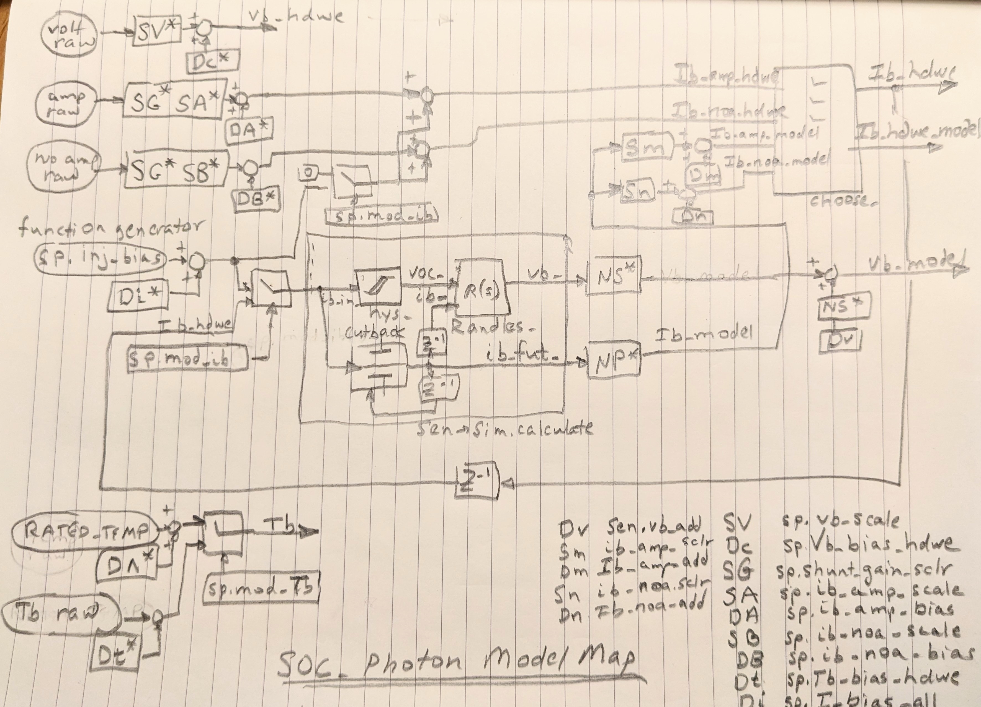Figure 2: Functional Block Diagram of User Interface to Application SOC_Particle

Synchronization
This refers to real time latencies, not clock time. I chose to implement a 'loose synchronization' method. Frames are formed by timers called each pass of 'loop().' If time is up for a frame, a boolean is set and any logic associated with the frame is then enables. It becomes 'loose' when events and user input introduce slippage in the frame. I do this for flexibility and to run the application as fast as possible. This application is not time critical. By that there is no feedback control that requires high fidelity dynamic calculation. But I reuse and ecosystem of synchronization used on time critical applications where running as fast as possible is desirable.
The key technology to enable loose synchronization are dynamic digital signal processing algorithms that handle variable update time. My library of functions calculate difference equation coefficients each update for the measured update time.
Dynamic difference equations are aliased – unstable – if they are called too infrequently for the dynamic eigenvalues specified for the algorithm. The library assumes that whatever time slippage occurs is a rare occurrence. The user determines the stable update time for each instance and limits the numerical value of update time supplied to the algorithm call to the stable range. This technique limits the destabilizing spikes that occur with coefficients recalculated with unstable update time. The occurrence is rare. By the next 'loop()' call, maybe even a few calls, the algorithm has a chance to resume normal operation with a slight glitch.
The glitches tend to be stabilizing, quieting, because update time is less than actual so they are difficult to spot.
Data saved from the application drives the over-plot model. The glitches appear in the over-plot response in an identical way as in the application so they are impossible to see in a plot.

Initialization
Dynamic algorithms require a happy initial condition for the states. On power-up, the initial first few passes are reserved for sensing the initial conditions and iterating the various 'use-before-calculate' situations. To speed this up, the application has a 'initialize_all()' function that attempts to perform this in one pass.

The one-wire temperature sensor sometimes requires up to a minute to provide converted values. A special 'reset_temp' flag manages this on power up, extending the initialization period until the first good value appears. After initialization, there are rate limits on the converted temperature values to prevent latency from spiking the logic and confusing filters. Fortunately, the battery monitoring algorithms are not very sensitive to temperature changes at the occurrence rate they occur.

It is possible to re-initialize on the fly. When the user requests the monitor to be at a different charge state, for some off-line testing of the logic for example, the synchronization ecosystem will turn on the 'reset' flags to force this to happen as on a normal power-up.

Because 'sat' is a UBC, when calling 'count_coulombs()' we have to tell it that we expect to call it again and it should set the 'resetting_' sticky bit upon exit. For that, we set the 'resetting' (no underscore) input flag.

A significant simplification is possible to initialize the off line over-plot model. The data drives the model and thus must initialize to the same condition to be useful. Rather than develop a separate initialization ecosystem for the model, it simply initializes to the incoming data. The incoming data carries flags names 'reset' or 'reset_temp' that tell the model when to do this. The re-initialization events occur seamlessly too.

Reliability Concept
There is dual current sense hardware. With flat battery voc(soc), current sensing and associated Coulomb Counting integration are critically important to the proper and accurate functioning of this device. This would be true no matter how sophisticated the modeling and filtering employed.

Third current signal constructed using voltage feedback, and EKF and voc(soc). The EKF's first function is to solve VOC from SoC. An on-line solver was initially used and replaced by the EKF because the EKF has features that buy it's way on. The EKF has two probability inputs: one is the confidence in the voltage sensor and the second is confidence in the process model SoC. By favoring the SoC (integration of doubly-redundant current a.k.a. Coulomb Counting) the EKF automatically switches and rejects a failed voltage (or bad voc(soc) curve or bad hysteresis model). If the doubly redundant currents disagree, the EKF can then moderate to isolate the bad current signal. Triplex current sensing is manufactured by system design.

The shunt device and wiring are prime reliable. This is a declaration that the system cannot detect or replace them. However failure is tested and the failure modes are graceful. For example, there is 'quiet' logic that detects disconnected wiring and/or shunt failure and displays a 'conn' status on the OLED.

Note that an important feature of this scheme is annunciation and user intervention. Once the triplex logic isolates a failure it is in a mode where further isolation is not much better than a coin toss. How do you choose between two different wrist watches telling different time? If the user repairs a failure soon after annunciation then exposure to multiple failure scenario is negligible.

Power loss is a normal event. They are caused by user action and by the BMS. To protect LiFeP04 chemistry, the BMS shuts off charging below 0 C and shuts off usage below 10v. Features are added to Count Coulombs and monitor faults in presence of normal power loss occurrence.

Except for shutting off, the Battleborn batteries are sensitive to temperature. Accuracy is improved with sensor but not terribly. The most likely consequence of temperature sensor loss would be an unexpected BMS shutoff for low temperature while the device is predicting good time remaining. Temperature sensor failures are monitored and displayed so the user can take action to reduce exposure.

Real-Time Monitoring
There are three possible ways:
- Connect CoolTerm to the USB
- Connect phone UART terminal to the USB
- Monitor HC-06 standard Bluetooth Serial Output
All use the 'Serial' and 'Serial1' APIs in the Particle Workbench tools. 'Serial' is connected to the USB TX/RX. 'Serial' is used for all heavy troubleshooting and testing. Various levels of verbosity print various styles of monitoring. Verbosity level 0, 'v0', transmits nothing on 'Serial.' Level 1, 'v1' is the most basic data stream. So on. Type 'h' to get a list of options. 'Serial1' content is a subset of 'Serial' content connected to Bluetooth TX/RX. 'Serial1' is useful for daily quick check. The level 0, 'v0', form reproduces the OLED display on the Bluetooth monitor.
Appendix 2: Regression Suite has lots of examples.

Post Process Monitoring
High sample rate is needed to properly book-keep current integration for spikes. Once that is verified and built in the device build the monitoring process may have as long as 30 minutes between data points. Sensor failures are on the order of 10 seconds between data points. Two circular buffers manage this data collection. Seven points are captured for any critical sensor failure and that buffer frozen until manually reset. It may be downloaded using any of the three monitoring methods. Any and all excess memory is used for the history. The Argon PLCs have some extra EERAM beyond what's needed for sensor failures. And the Argon PLCs have extra PRAM to access as long as the PLC is not depowered. All these are available using any of the three monitoring methods.

Resistor Quality
The temperature range for this device is about 0C for a heated battery up to about 40C on hot summer day. This is a small swing and 5% resistors would show about 1% effect. And since the battery hysteresis, variation, life and the need to calibrate for installation effects drive accuracy, the resistor quality could be poor. This is unnecessary because the high quality resistors are negligibly more expensive. In the future, 1% 1/4 watt resistors should be procured.

Cost

Battery Heating
For some expenditure of charge, the battery can remain available for full functioning charge and discharge even when temperature outside, or inside the unheated RV, drop below the level where the battery management system (BMS) would normally shut off the terminals. The BMS, present in all LiFeP04 batteries, does this to prevent damage to the chemistry. This is all independent of sunshine, as many RVs, including mine, charge from the engine too.

The limit of this feature is somewhere below -5F. Any colder and the battery expends all its energy overnight keeping warm leaving nothing left to run a CPAP machine.

Heating pads are wrapped around the sides of the battery and another temperature sensor, as well as the monitor's temperature sensor, are inserted underneath the pad between the heaters and the battery. An old foam camping pad is wrapped around it all. A special circuit, usually used to heat chicken brooders, monitors this other sensor and routes battery power to the heaters. The circuit has an adjustable on-off set-point and hysteresis. I found that 40 – 45 F (4.4 – 7.2 deg C) works well as a practical matter. The spreadsheet 'Truck Camping ALL STUFF.gsheet' tab 'Settings'. There is a link to this in Appendix 3. Links.

Heating is done only from the sides

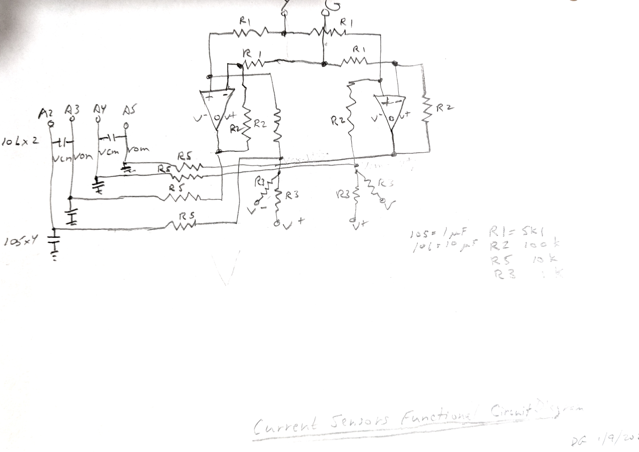Figure 3: Current Sensors Functional Circuit Diagram

## Hardware notes

Grounds all tied together to solar ground and also to chassis.
Typically operate for data with laptop plugged into inverter and connected to microUSB on Particle device
Can run 500 W discharge using flood light plugged into inverter
Can run 500 W charge from alternator DC-DC converter (breaker under hood; start engine)

### Calibrating mV - A

Before installation, use a power supply to calibrate the current sensor gain and offset

You need a clamping ammeter. Basic. Best way to get the slope of the conversion. A 100A/.075V shunt is nominally 1333 A/V.

Do a discharge-charge cycle to get a good practical value for the bias of the conversion. Calculate integral of A over cycle and get endpoint to match start point. This will also provide a good estimate for battery capacity to populate the model. (R1 visible easily).

Tweak logic could be used to get rid of drift of small A measurement. This integrates each freely counted current input and compares endpoints after long cycle. Should be no difference. If there is, tweak. Not implemented - not worth complexity.

>13.7 V is decent approximation for SoC>99.7, correct for temperature.

Temperature correction in ambient range is about BATT_DVOC_DT=0.001875 V/deg C from 25 * number of cells = 4. This is estimated from the Battleborn characterization model I performed.

The ADS module is delicate (ESD and handling). I burned one out by
accidentally touching terminals to back of OLED board. I now mount the
OLED board carefully off to the side. Will need a hobby box to contain the final device

## Accuracy

1. Current Sensor
a. Gain - component calibration at install
b. Bias - component calibration at install
c. Drift - Tweak test (not implemented)
d. Amplifiers. There is a chip (TSC2010-IDT, https://www.digikey.com/en/products/detail/stmicroelectronics/TSC2011IYDT/13244059, 20x for 3.3v and 0.075 shunt) that creates one voltage signal for differential action. That will reduce complexity, use fewer A/D, and be more accurate.
2. Voltage Sensor
3. Temperature Sensor
4. Hysteresis Model
5. Coulombic Efficiency and Drift
6. Coulomb Counter
a. Temperature derivative on counting is a new concept. I believe I am pioneering this idea of technology. That the temperature effects are large enough to fundamentally increase the order of Coulomb Counting.
b. My notion seems to be backed up by high sensitivity
7. Dynamic Model
a. Not sure this is even needed to due to low bandwidth of daily charge cycle. Average out.
b. Leave this in design for now for study. Able to disable
8. EKF
a. Failure isolation
b. A-hr displayed on OLED for reference - quick check on EKF.
9. Redundancy
a. Virtual triplex Ib_Amp, Ib_No-amp, Vb

## Calibration checklist
1. Delta adjustment for Vb.
2. Nothing to do for Tb. If heater kit, make sure Tb is inside the jacket next to the battery case.
3. Collect extreme ranges of data.
a. 0, +/- 0.3C (30% of max A-h capacity in A)
b. S/W: Ib amp, Ib no amp, Vb
c. Hardware: clamp multi-meter next to shunt, multi meter on Vb
4. Use spreadsheet to estimate first order polynomial fit to current data. Checks bias and gain for linearity. These devices are linear so if that's not what is seen on plots, check data.
5. To date, my work has not been precise enough to see temperature dependence on shunt calibration.
6. Real runs using battery heater to establish VOC(SoC, Tb) and determine capacity, which should be > rating.

## Boot checklist - after new software load
1. Synchronize time if necessary. Use hotspot on phone. Press left button and hold 3 sec to get blink blue. Use particle app to '+' device. Reset using right button to complete the process. Time is UTC. Unfortunately for device soc1a, the bar code on the Argon is hidden inside the case. Then you must use the talk('U') feature of the interface programs. This will work over Bluetooth for Argon. Use Unix Epoch website and subtract (hours from Zulu)* 3600 and paste onto U.
2. Update the version in local_config.h for 'unit ='.
3. Start CoolTerm record. Record Hd, Pf, Pa, brief v1 burst for the previous load.
4. On restart after load, check the retained parameter list (SRAM battery backed up). The list is displayed on startup for convenience. Go slowly with this if you've been tuning.
5. Record Hd, Pf, Pa, brief v1 burst. Confirm the 'unit =' is for the intended build install.
6. Check Xm=0 before walk away from installed system.

## Throughput
1. Driven by ADC read of ADS1013 device (current AD). For Argon with EERAM 47L16 it is ADC write of parameters at 0.001 each. Manage this with blink logic in put_all_dynamic() of 'SavedPars' object, called with display update time DISPLAY_USER_DELAY (1.2 sec) in ino file.
2. There is a 6×1.2 delay between some transient events and when it is remembered by the EERAM. If you're pushing buttons rapidly and repeating scripts you may run into stale data issue especially remembered charge states 'delta_q...' --> soc...
3. Probably wiring quality drives the conversion count for (busy wait for I2C comm). Or could be flaky ADS devices.
4. Per unit
pro0p: amp 62 cts, 0.0320 sec; noa 200 cts, 0.0460 sec
soc0p:
pro1a: amp 46 cts, 0.0330 sec; noa 1 cts, 0.0030 sec
soc1a: delete ADS: ~0.0015 sec

Dynamic Randles Model

Dynamic Hysteresis Model

Coulombic Efficiency
aking sure the scaling parameters are duplicated in the off-line model as parameter inputs input by hand.

Recommendations
- Procure TSC2010-IDT chips going forward.
- Procure 1% 1/4 watt resistors going forward.

Appendix 1. Nomenclature

Application | Off-line | Description
tau_ct | tau_ct | Battery chemistry charge transfer time constant, s
tau_dif | tau_dif | Battery chemistry diffusion time constant, s
r_ct | r_ct | Battery chemistry charge transfer resistance, Ohm
r_dif | r_dif | Battery chemistry diffusion resistance, Ohm
r_sd | r_sd | Battery chemistry lumped parameter Randles model equivalent resistance, Ohm
r0 | r0 | Battery chemistry direct resistance, Ohm
 | sres_in | Scalar applied to all Randles model resistances for off-line tuning

Appendix 2: Regression Suite
- All these must self initialize – correct the application until they do
- You have to start and stop data recording. Use ctr-R and shift-ctr-R in CoolTerm. You may use Arduino Serial but it is a little messier because it doesn't support multiple windows.
- Open two talk windows (ctr-T in CoolTerm) and copy-paste the two lines in the talk windows (start and reset in items below)
- Initiate by starting a recording (ctr-R) and running start line in first talk. Those without a second line self-terminate. You still have to stop recording (shift-ctr-R).
- Terminate by watching for reset of failure condition (or wait long enough) and running second line in second talk.
- Move to pyCharm and run 'CompareRunSim' after proper comment/uncomment in 'data_file_old_txt' assignment.
- Running with a bare device, need to set the modeling dscn bits 16, 32, 64, and 128. (Add 240 to whatever Xm you normally run with, e.g. 7 becomes 247 for fully bare and modeled.)
- The second lines below are to reset. I recommend opening a second transmit window if using CoolTerm to have these ready to go.
- Copy and paste the lines into CoolTerm 'transmit' windows (ctr-T). Or run in line mode (Options – Terminal – Line Mode) and use communication bar like in Arduino Serial App still copy and paste.
- Example set of plots, from offSitHysBms begin here: Figure 4.

ampHiFail:
start: Ff0;D^0;Xm247;Ca0.5;Dr100;DP1;HR;Pf;v2;W30;Dm50;Dn0.0001;
reset: Hs;Hs;Hs;Hs;Pf;DT0;DV0;DM0;DN0;Xp0;Rf;W200;+v0;Ca.5;Dr100;Rf;Pf;DP4;
    - Should detect and switch amp current failure (reset when current display changes from '50/diff' back to normal '0' and wait for CoolTerm to stop streaming.)
    - 'diff' will be displayed. After a bit more, current display will change to 0.
    - To evaluate plots, start looking at 'DOM 1' fig 3. Fault record (frozen). Will see 'diff' flashing on OLED even after fault cleared automatically (lost redundancy).

rapidTweakRegression:
start: Ff0;HR;Xp10;
  - Should run three very large current discharge/recharge cycles without fault
  - Best test for seeing time skews and checking fault logic for false trips
rapidTweakRegression vA CH: Bm1;Bs1;SQ1.127;Sq1.127;Ff0;HR;Xp10; for CompareRunRun.py Argon vs Photon builds. This is the only test for that.

offSitHysBms: operate around BMS off, starting above from about 11v, go below, come back up. EXAMPLE PLOTS START HERE: Figure 4.
start: Ff0;D^0;Xp0;Xm247;Ca0.05;Rb;Rf;Dr100;DP1;Xts;Xa-162;Xf0.004;XW10;XT10;XC2;W2;Ph;HR;Pf;v2;W5;XR;
reset: XS;v0;Hd;Xp0;Ca.05;W5;Pf;Rf;Pf;v0;DP4;
    - Best test for seeing Randles model differences. No faults
    - Only test to confirm on/off behavior. Make sure comes back on.
    - It will show one shutoff only since becomes biased with pure sine input with half of down current ignored on first cycle during the shuttoff.
    - reset_s_ver because device reset on power up
offSitHysBms CH: Ca0.014;

triTweakDisch:
start: Ff0;D^0;Xp0;v0;Xm15;Xtt;Ca1.;Ri;Mw0;Nw0;MC0.004;Mx0.04;NC0.004;Nx0.04;Mk1;Nk1;-Dm1;-Dn1;DP1;Rb;Pa;Xf0.02;Xa-29500;XW5;XT5;XC3;W2;HR;Pf;v2;W2;Fi1000;Fo1000;Fc1000;Fd1000;FV1;FI1;FT1;XR;
reset: v0;Hd;XS;Dm0;Dn0;Fi1;Fo1;Fc1;Fd1;FV0;FI0;FT0;Xp0;Ca1.;Pf;DP4;
    - Should run three very large triangle wave current discharge/recharge cycles without fault.

coldStart:
start: Ff0;D^-18;Xp0;Xm247;Fi1000;Fo1000;Ca0.93;Ds0.06;Sk0.5;Rb;Rf;Dr100;DP1;v2;W100;DI40;Fi1;Fo1;
reset: DI0;W10;v0;W5;Pf;Rf;Pf;v0;DP4;D^0;Ds0;Sk1;Fi1;Fo1;Ca0.93;
    - Should charge for a bit after hitting cutback on BMS. Should see current gradually reduce. Run until 'SAT' is displayed. Could take ½ hour.
    - The Ds term biases voc(soc) by delta x and makes a different type of saturation experience, to accelerate the test.
    - Look at chart 'DOM 1' and verify that e_wrap misses ewlo_thr (thresholds moved as result of previous failures in this transient)
    - Don't remember why this problem on cold day only.

ampHiFailFf:
start: Ff1;D^0;Xm247;Ca0.5;Dr100;DP1;HR;Pf;v2;W30;Dm50;Dn0.0001;
reset: Hs;Hs;Hs;Hs;Pf;Hd;Ff0;DT0;DV0;DM0;DN0;Xp0;Rf;W200;+v0;Ca.5;Dr100;Rf;Pf;DP4;
- Should detect but not switch amp current failure. (See 'diff' and current!=0 on OLED).
- Run about 60s. Start by looking at 'DOM 1' fig 3. No fault record (keeps recording). Verify that on Fig 3 the e_wrap goes through a threshold ~0.4 without tripping faults.

ampLoFail:
start: Ff0;D^0;Xm247;Ca0.5;Dr100;DP1;HR;Pf;v2;W30;Dm-50;Dn0.0001;
reset: Hs;Hs;Hs;Hs;Pf;DT0;DV0;DM0;DN0;Xp0;Rf;W200;+v0;Ca.5;Dr100;Rf;Pf;DP4;
- Should detect and switch amp current failure.
- Start looking at 'DOM 1' fig 3. Fault record (frozen). Will see 'diff' flashing on OLED even after fault cleared automatically (lost redundancy).

ampHiFailNoise:
start: Ff0;D^0;Xm247;Ca0.5;Dr100;DP1;HR;Pf;v2;W30;DT.05;DV0.05;DM.2;DN2;W50;Dm50;Dn0.0001;Ff0;
reset: Hs;Hs;Hs;Hs;Pf;DT0;DV0;DM0;DN0;Xp0;Rf;W200;+v0;Ca.5;Dr100;Rf;Pf;DP4;
- Noisy ampHiFail. Should detect and switch amp current failure.
- Start looking at 'DOM 1' fig 3. Fault record (frozen). Will see 'diff' flashing on OLED even after fault cleared automatically (lost redundancy).

rapidTweakRegression40C:
start: Ff0;HR;D^15;Xp10;
reset: D^0;
- Should run three very large current discharge/recharge cycles without fault

slowTweakRegression:
start: Ff0;HR;Xp11;
reset: self terminates
- Should run one very large slow (~15 min) current discharge/recharge cycle without fault. It will take 60 seconds to start changing current.

satSit:
start: Ff0;D^0;Xp0;Xm247;Ca0.993;Rb;Rf;Dr100;DP1;Xts;Xa17;Xf0.002;XW10;XT10;XC1;W2;HR;Pf;v2;W5;XR;
reset: XS;v0;Hd;Xp0;Ca.9962;W5;Pf;Rf;Pf;v0;DP4;
- Should run one saturation and de-saturation event without fault. Takes about 15 minutes.
- operate around saturation, starting below, go above, come back down. Tune Ca to start just below vsat
- satSit CH: Ca0.993

flatSitHys:
start: Ff0;D^0;Xp0;Xm247;Ca0.9;Rb;Rf;Dr100;DP1;Xts;Xa-81;Xf0.004;XW10;XT10;XC2;W2;Ph;HR;Pf;v2;W5;XR;
reset: XS;v0;Hd;Xp0;Ca.9;W5;Pf;Rf;Pf;v0;DP4;
- Operate around 0.9. For CHINS, will check EKF with flat voc(soc). Takes about 10 minutes.
- Make sure EKF soc (soc_ekf) tracks actual soc without wandering.

offSitHysBmsNoise:
start: Ff0;D^0;Xp0;Xm247;Ca0.05;Rb;Rf;Dr100;DP1;Xts;Xa-162;Xf0.004;XW10;XT10;XC2;W2;DT.05;DV0.10;DM.2;DN2;Ph;HR;Pf;v2;W5;XR;
reset: XS;v0;Hd;Xp0;DT0;DV0;DM0;DN0;Ca.05;W5;Pf;Rf;Pf;v0;DP4;
- Stress test with 2x normal Vb noise DV0.10. Takes about 10 minutes.
- operate around saturation, starting above, go below, come back up. Tune Ca to start just above vsat. Go low enough to exercise hys reset
- Make sure comes back on.
- It will show one shutoff only since becomes biased with pure sine input with half of down current ignored on first cycle during the shuttoff.

ampHiFailSlow:
start: Ff0;D^0;Xm247;Ca0.5;Pf;v2;W2;Dr100;DP1;HR;Dm6;Dn0.0001;Fc0.02;Fd0.5;
reset: Hd;Xp0;Pf;Rf;W2;+v0;Dr100;DE20;Fc1;Fd1;Rf;Pf;
- Should detect and switch amp current failure. Will be slow (~6 min) detection as it waits for the EKF to wind up to produce a cc_diff fault.
- Will display “diff” on OLED due to 6 A difference before switch (not cc_diff).
- EKF should tend to follow voltage while soc wanders away.

vHiFail:
start: Ff0;D^0;Xm247;Ca0.5;Dr100;DP1;HR;Pf;v2;W50;Dv0.8;
reset: Dv0;Hd;Xp0;Rf;W50;+v0;Dr100;Rf;Pf;DP4;
- Should detect voltage failure and display '*fail' and 'redl' within 60 seconds.
- To diagnose, begin with DOM 1 fig. 2 or 3. Look for e_wrap to go through ewl_thr.
- You may have to increase magnitude of injection (Dv). The threshold is 32 * r_ss.

vHiFailFf:
start: Ff1;D^0;Xm247;Ca0.5;Dr100;DP1;HR;Pf;v2;W50;Dv0.8;
reset: Dv0;Ff0;Hd;Xp0;Rf;W50;+v0;Dr100;Rf;Pf;DP4;
  - Run for about 1 minute.
  - Should detect voltage failure (see DOM1 fig 2 or 3) but not display anything on OLED.

pulseEKF: Xp6 # TODO: doesn't work now.

pulseSS: Xp7
  - Should generate a very short <10 sec data burst with a pulse. Look at plots for good overlay. e_wrap will have a delay.
  - This is the shortest of all tests. Useful for quick checks.

tbFailMod:
start:Ff0;D^0;Ca.5;Xp0;W4;Xm247;DP1;Dr100;W2;HR;Pf;v2;Xv.002;Xu1;W200;Xu0;Xv1;W100;v0;Pf;
reset:Hd;Xp0;Xu0;Xv1;Ca.5;v0;Rf;Pf;DP4;
  - Run for 60 sec. Plots DOM 1 Fig 2 or 3 should show Tb was detected as fault but not failed.

tbFailHdwe: This script sometimes doesn't work but test performs fine manually
start:Ff0;D^0;Ca.5;Xp0;W4;Xm246;DP1;Dr100;W2;HR;Pf;v2;Xv.002;W50;Xu1;W200;Xu0;Xv1;W100;v0;Pf;
reset: Hd;Xp0;Xu0;Xv1;Ca.5;v0;Rf;Pf;DP4;
  - Should momentary flash '***' then clear itself. All within 60 seconds.
  - 'Xp0' in reset puts Xm back to 247.

Special Testing (e.g. Gorilla Testing)

Scale battery
App: NOM_UNIT_CAP in local_config.h
Python: scale_in in CompareRunSim.py or CompareRunRun.py (+Battery. NOM_UNIT_CAP)
Notes: talk 'Sc' scales the on-board model in BatterySim only, not BatteryMonitor
dwell noise Ca.5:
Ff0;HR;Di.1;Dv0;Dr100;DP1;v4;Ca.5;DT.05;DV0.05;DM.2;DN2;
Xp0;v0;Hd;DT0;DV0;DM0;DN0;Di0;Dv0;DP4;
# Dwell for >5 minutes. This operating condition found EKF failure one time. Led to multi-framing the EKF (update time = 2.0). Before change, update time of EKF was so short (0.1) that internal filter parameters were truncating. When plotted shows EKF staying on point, not wandering off. Beware, a dwell has most parameters changing slowly. Auto-scaling in python plots combined with truncation in data stream (but not python) makes some interesting artifacts.

dwell Ca.5:
Ff0;HR;Di.1;Dr100;DP1;v4;Ca.5;
Xp0;v0;Hd;DT0;DV0;DM0;DN0;Di0;Dv0;DP4;
# Dwell for >5 minutes. This operating condition found EKF failure one time. Led to multi-framing the EKF (update time = 2.0). Before change, update time of EKF was so short (0.1) that internal filter parameters were truncating. When plotted shows EKF staying on point, not wandering off. Auto-scaling in python plots combined with truncation in data stream (but not python) makes some interesting artifacts.

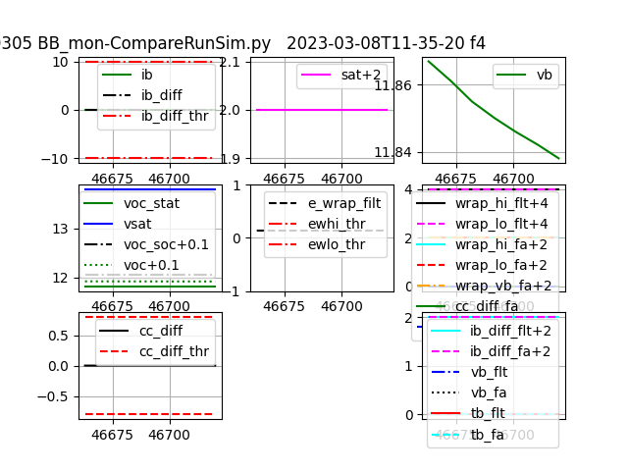Figure 4: offSitHysBms Test Figure 1
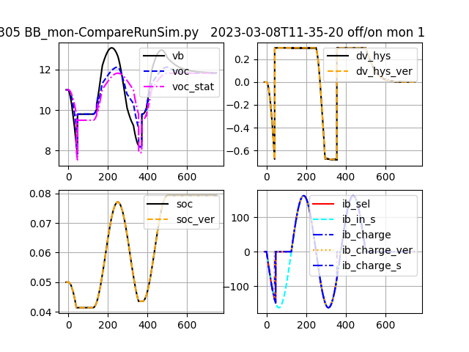Figure 5: offSitHysBms Test Figure 2
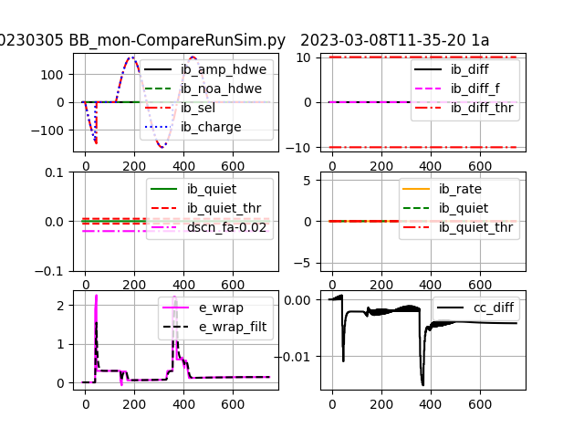Figure 6: offSitHysBms Test Figure 3
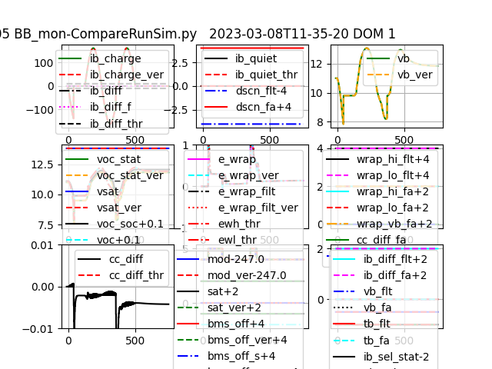Figure 7: offSitHysBms Test Figure 4
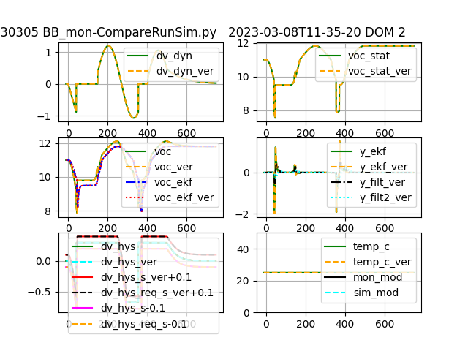Figure 8: offSitHysBms Test Figure 5
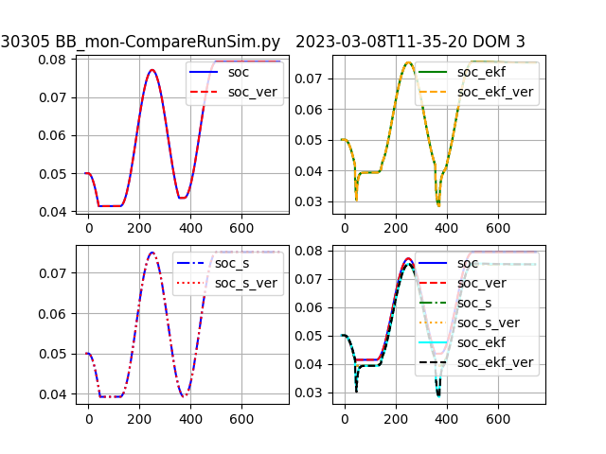Figure 9: offSitHysBms Test Figure 6
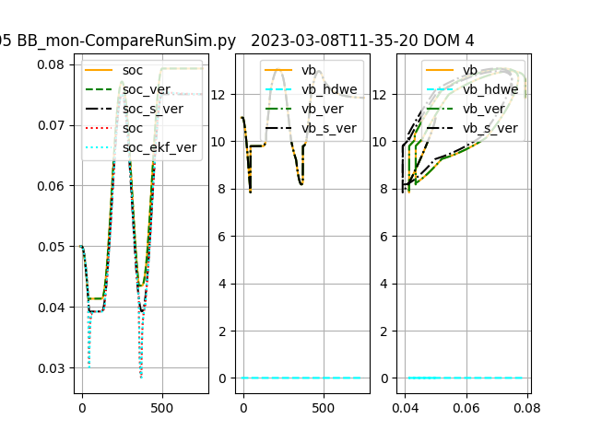Figure 10: offSitHysBms Test Figure 7
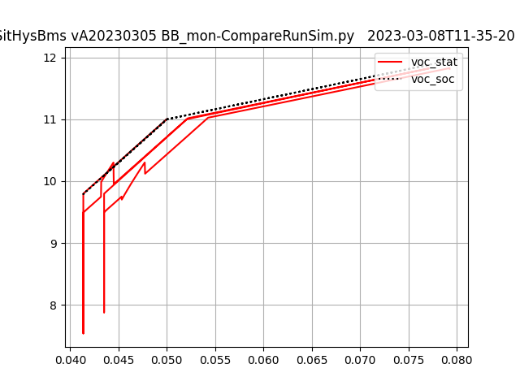Figure 11: offSitHysBms Test Figure 8
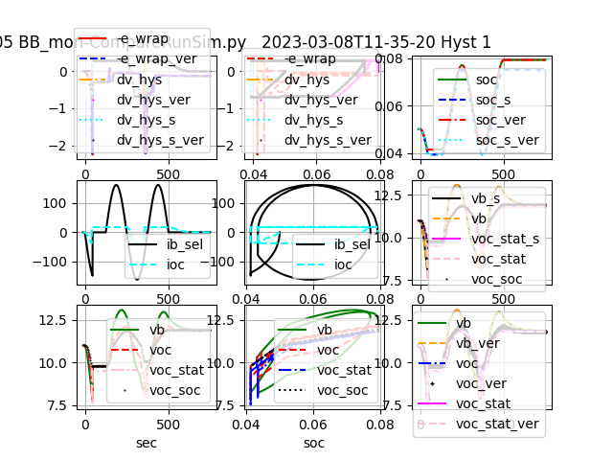Figure 12: offSitHysBms Test Figure 9
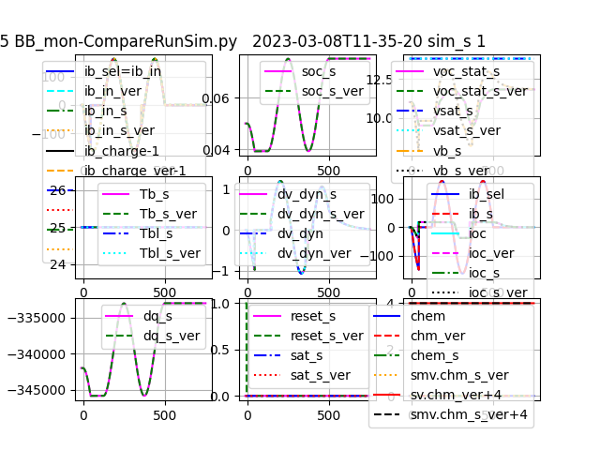Figure 13: offSitHysBms Test Figure 10
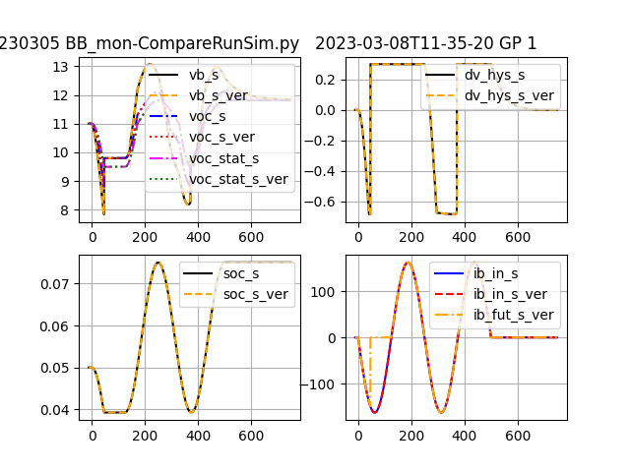Figure 14: offSitHysBms Test Figure 11
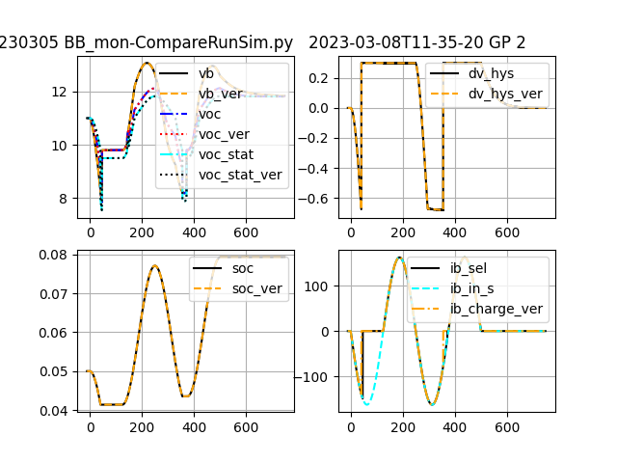Figure 15: offSitHysBms Test Figure 12
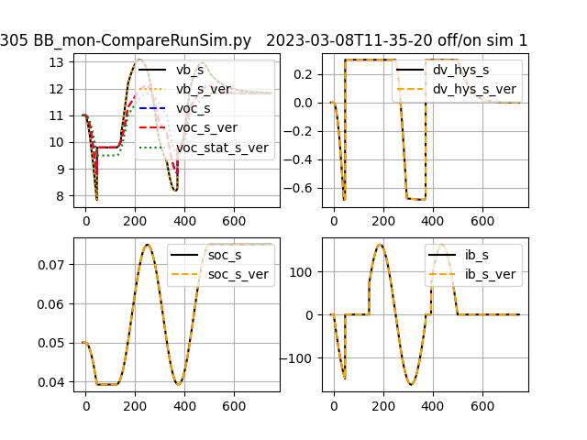Figure 16: offSitHysBms Test Figure 13
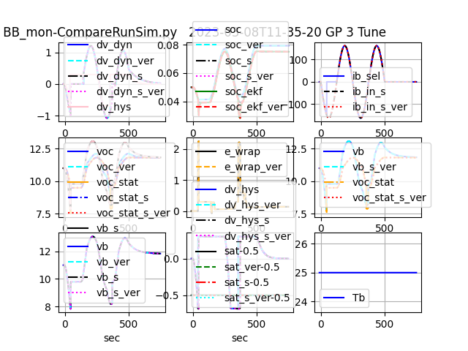Figure 17: offSitHysBms Test Figure 14

Appendix 3. Links
'Truck Camping ALL STUFF.gsheet' Multiple tabbed spreadsheet of parts manifest, settings, hardware schematics, and what all. https://docs.google.com/spreadsheets/d/19PZ2GmKIlw14doqwePp9xxWH96coLm8WmXdIwlzdxjE/edit#gid=167481175

